Mpho Motswaiso
Cse25-426
The Gasket Lab Botswana
Web and multimedia development project

Website Objective: The purpose of the Gaborone Auto Repair website is to attract local vehicle owners, clearly display our repair services, allow easy online booking, and build trust so customers choose us instead of competitors.
Business Goals:
- Increase workshop bookings
- Show real customer testimonials and before/after photos
- Provide 24/7 contact and price information
- Boost online presence through advertising
- Improve our technicians’ skills and range
- Optimize cost of goods sold (car parts) and labour pricing to increase net profitability.
Target Audience: Men and women aged 25–70 living in Botswana. They own sedans, SUVs or light trucks, have moderate technical skills (they regularly use WhatsApp, Google Maps and online banking applications), and want hospitable, fast, honest service at fair prices.
Type of Website: A professional service/business website focused on automotive repairs with an online contact/feedback form.
This here is the logo of The Gasket Lab Botswana designed using CorelDraw:
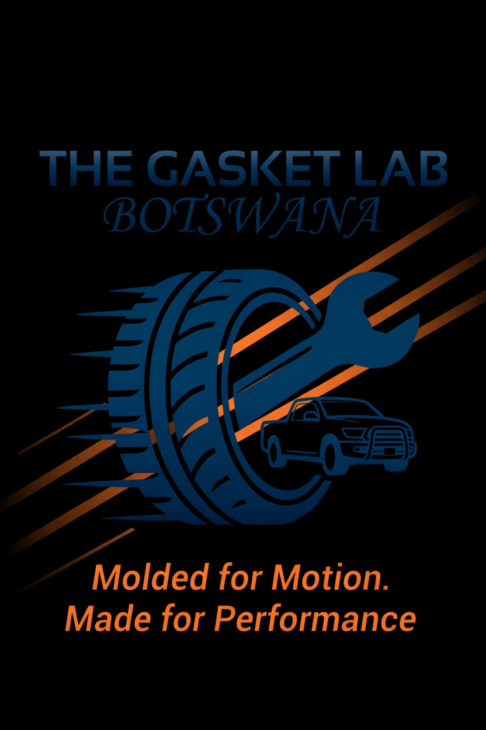
Site Map (all pages will be connected for easy navigation):
- Home (index.html)
- Services
- About Us
- Gallery
- Contact / Feedback (with form)
Navigation: Every page has the same top menu: Home | Services | About | Gallery | Contact 3-click rule is followed – any page is reachable in maximum 2 clicks.
Storyboard Flowchart (draw this simple box diagram in Word or PowerPoint and screenshot it into the report): Home - Services - Specific Service (e.g. Brake Repair) Home - Contact (feedback form) All arrows go back to Home for easy return.
Technologies and tools I will use:
- VS Code – free and powerful code editor
- HTML5 for structure
- My own external CSS3 file (style.css) for custom styling
- Bootstrap 5 framework for perfect mobile responsiveness
- JavaScript for form validation and smooth effects
- CorelDraw– used to create the logo, banners and service icons (logo is already complete)
- GitHub and GitHub Pages for free hosting and version control
- Google Fonts for clean, professional typography
These tools perfectly match the complexity of a clean 5-page automotive website – nothing is overkill or missing.

